STATEMENT LEVEL CONTROL STRUCTURES

- Introduction
- Selection Statements
- Iterative Statements
- Unconditional Branching
- Guarded Commands
- Conclusions

INTRODUCTION

Computations in imperative-language programs are accomplished by evaluating expressions and assigning the resulting values to variables. Meanwhile useful programs are not only made up of assignments statements entirely at least two additional linguistic mechanisms are necessary to make the computations in programs flexible and powerful: some means of selecting among alternative control flow paths (of statement execution) and some means of causing the repeated execution of statements or sequences of statements. Statements that provide these kinds of capabilities are called control statements.

The control statements of the first successful programming language, Fortran, were, in effect, designed by the architects of the IBM 704. All were directly related to machine language instructions, so their capabilities were more the result of instruction design rather than language design. At the time, little was known about the difficulty of programming, and, as a result, the control statements of Fortran in the mid-1950s were thought to be entirely acceptable. By today’s standards, however, they are considered wholly inadequate.
The first of such control statement was a selectable GOTO statement. This was fund to be potentially useful but not essential. This fact, combined with the practical problems of using unconditional branches, or gotos, led to a great deal of debate about the goto.
A control structure is a control statement and the collection of statements whose execution it controls.

SELECTION STATEMENTS

A selection statement provides the means of choosing between two or more execution paths in a program. Such statements are fundamental and essential parts of all programming languages, as was proven by Böhm and Jacopini. Selection statements fall into two general categories: two-way and n-way, or multiple selection.

TWO-WAY SELECTION STATEMENTS

Although the two-way selection statements of contemporary imperative languages are quite similar, there are some variations in their designs. The general form of a two-way selector is as follows:
if control_expression
then clause
else clause
Design Issues The design issues for two-way selectors can be summarized as follows:
• What is the form and type of the expression that controls the selection?
• How are the then and else clauses specified?
• How should the meaning of nested selectors be specified?

The Control Expression

Control expressions are specified in parentheses if the then reserved word (or some other syntactic marker) is not used to introduce the then clause. In those cases where the then reserved word (or alternative marker) is used, there is less need for the parentheses, so they are often omitted. In python and C++ Boolean data type, arithmetic expressions were used as control expressions. In other contemporary languages, only Boolean expressions can be used for control expressions.

Clause Form
In many contemporary languages, the then and else clauses appear as either single statements or compound statements. One variation of this is Perl, in which all then and else clauses must be compound statements, even if they contain single statements. Many languages use braces to form compound statements, which serve as the bodies of then and else clauses. In Python, the then and else clauses are statement sequences, rather than compound statements. The complete selection statement is terminated in these languages with a reserved word.
Python uses indentation to specify compound statements. For example,
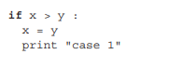
All statements equally indented are included in the compound statement.2 Notice that rather than then, a colon is used to introduce the then clause in Python. The variations in clause form have implications for the specification of the meaning of nested selectors.
NESTING SELECTORS
When a selection statement is nested in the then clause of a selection statement, it is not clear to which if an else clause should be associated. This problem is reflected in the semantics of selection statements. Consider the following Java-like code:

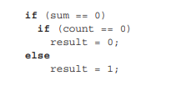
This statement can be interpreted in two different ways, depending on whether the else clause is matched with the first then clause or the second. Notice that the indentation seems to indicate that the else clause belongs with the first then clause. However, with the exceptions of Python and F#, indentation has no effect on semantics in contemporary languages and is therefore ignored by their compilers.
The crux of the problem in this example is that the else clause follows two then clauses with no intervening else clause, and there is no syntactic indicator to specify a matching of the else clause to one of the then clauses.

Multiple-Selection Statements
The multiple-selection statement allows the selection of one of any number of statements or statement groups. It is, therefore, a generalization of a selector. In fact, two-way selectors can be built with a multiple selector. The need to choose from among more than two control paths in a program is common. Although a multiple selector can be built from two-way selectors and gotos, the resulting structures are cumbersome, unreliable, and difficult to write and read. Therefore, the need for a special structure is clear.
The following is a summary of design issues with multiple selection statements:
• What is the form and type of the expression that controls the selection?
• How are the selectable segments specified?
• Is execution flow through the structure restricted to include just a single selectable segment?
• How are the case values specified?
• How should unrepresented selector expression values be handled, if at all?

Examples of Multiple Selectors:
The C multiple-selector statement, switch, which is also part of C++, Java, and JavaScript, is a relatively primitive design. Its general form is
switch (expression) {
case constant_expression1:statement1;
. . .
case constantn: statement_n;
[default: statementn+1]
}
where the control expression and the constant expressions are some discrete type. This includes integer types, as well as characters and enumeration types. The selectable statements can be statement sequences, compound statements, or blocks. The optional default segment is for unrepresented values of the control expression. If the value of the control expression is not represented and no default segment is present, then the statement does nothing.
The switch statement does not provide implicit branches at the end of its code segments. This allows control to flow through more than one selectable code segment on a single execution.
The following switch statement uses break to restrict each execution to a single selectable segment:
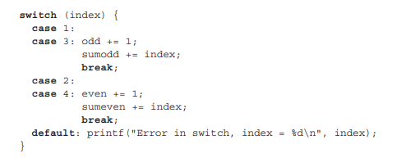
Multiple Selection Using if
In many situations, a switch or case statement is inadequate for multiple selection. For example, when selections must be made on the basis of a Boolean expression rather than some ordinal type, nested two-way selectors can be used to simulate a multiple selector. To alleviate the poor readability of deeply nested two-way selectors, some languages, such as Perl and Python, have been extended specifically for this use. The extension allows some of the special words to be left out. In particular, else-if sequences are replaced with a single special word, and the closing special word on the nested if is dropped. The nested selector is then called an else-if clause.
Consider the following Python selector statement (note that else-if is spelled elif in Python):

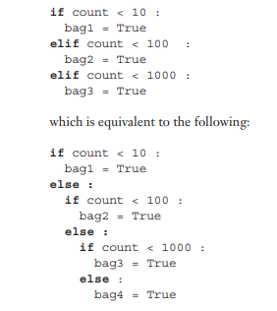
The else-if version (the first) is the more readable of the two. Notice that this example is not easily simulated with a switch statement, because each selectable statement is chosen on the basis of a Boolean expression. Therefore, the else-if statement is not a redundant form of switch. In fact, none of the multiple selectors in contemporary languages are as general as the if-then-else-if statement.

ITERATIVE STATEMENTS
An iterative statement is one that causes a statement or collection of statements to be executed zero, one, or more times. An iterative statement is often called a loop. Iteration is the very essence of the power of the computer. If some means of repetitive execution of a statement or collection of statements were not possible, programmers would be required to state every action in sequence; useful programs would be huge and inflexible and take unacceptably large amounts of time to write and mammoth amounts of memory to store. The first iterative statements in programming languages were directly related to arrays. This resulted from the fact that in the earliest years of computers, computing was largely numerical in nature, frequently using loops to process data in arrays. Several categories of iteration control statements have been developed.
The primary categories are defined by how designers answered two basic design questions:
• How is the iteration controlled?
• Where should the control mechanism appear in the loop statement?
The primary possibilities for iteration control are logical, counting, or a combination of the two. The main choices for the location of the control mechanism are the top of the loop or the bottom of the loop. The issue is not the physical placement of the control mechanism; rather, it is whether the mechanism is executed and affects control before or after execution of the statement’s body.
The body of an iterative statement is the collection of statements whose execution is controlled by the iteration statement. We use the term pretest to mean that the test for loop completion occurs before the loop body is executed and posttest to mean that it occurs after the loop body is executed. The iteration statement and the associated loop body together form an iteration statement.

Counter-Controlled Loops
A counting iterative control statement has a variable, called the loop variable, in which the count value is maintained. It also includes some means of specifying the initial and terminal values of the loop variable, and the difference between sequential loop variable values, often called the step size. The initial, terminal, and step size specifications of a loop are called the loop parameters.
The following is a summary of the design issues:
• What are the type and scope of the loop variable?
• Should it be legal for the loop variable or loop parameters to be changed in the loop, and if so, does the change affect loop control?
• Should the loop parameters be evaluated only once, or once for every iteration?

The for Statement of the C based Languages
The general form of C’s for statement is for (expression_1; expression_2; expression_3) loop body
The loop body can be a single statement, a compound statement, or a null statement. Because assignment statements in C produce results and thus can be considered expressions, the expressions in a for statement are often assignment statements. The first expression is for initialization and is evaluated only once, when the for statement execution begins. The second expression is the loop control and is evaluated before each execution of the loop body. As is usual in C, a zero value means false and all nonzero values mean true. Therefore, if the value of the second expression is zero, the for is terminated; otherwise, the loop body statements are executed
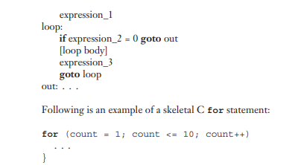
All of the expressions of C’s for are optional. An absent second expression is considered true, so a for without one is potentially an infinite loop. If the first and/or third expressions are absent, no assumptions are made. For example, if the first expression is absent, it simply means that no initialization takes place.

The for statement of Python
The general form of Python’s for is
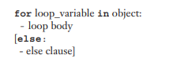
The loop variable is assigned the value in the object, which is often a range, one for each execution of the loop body. The else clause, when present, is executed if the loop terminates normally. Consider the following example:

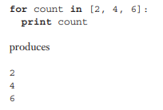
For most simple counting loops in Python, the range function is used. Range takes one, two, or three parameters. The following examples demonstrate the actions of range:
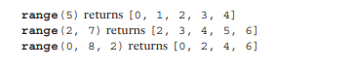
Note that range never returns the highest value in a given parameter range.

What is a function in Python?
In Python, a function is a group of related statements that performs a specific task.
Functions help break our program into smaller and modular chunks. As our program grows larger and larger, functions make it more organized and manageable.
Furthermore, it avoids repetition and makes the code reusable.

Syntax of Function
def function_name(parameters):
“ “ “docstring” “ “
Statement (s)
Above shown is a function definition that consists of the following components.
- Keyword def that marks the start of the function header.
- A function name to uniquely identify the function. Function naming follows the same rules of writing identifiers in Python.
- Parameters (arguments) through which we pass values to a function. They are optional.
- A colon (:) to mark the end of the function header.
- Optional documentation string (docstring) to describe what the function does.
- One or more valid python statements that make up the function body. Statements must have the same indentation level (usually 4 spaces).
- An optional return statement to return a value from the function.

Example of a function

def greet(name):

“ “ “

This function greets to the person passed in as parameter

“ “ “

Print(“Hello, “+ name +”. Good morning!”)

How to call a function in python?
Once we have defined a function, we can call it from another function, program or even the Python prompt. To call a function we simply type the function name with appropriate parameters.

>>>greet(“ Mr Paul”)
Hello, Mr Paul. Good morning

Running the code with the function definition
def greet(name):
“ “ “
This function greets the person passed in as a parameter
“ “ “
print(“Hello, “ + name + ” . Good morning!”)
greet( ‘Mr Paul’)

